Given a binary search tree, return a **balanced** binary search tree with the same node values.

A binary search tree is *balanced* if and only if the depth of the two subtrees of every node never differ by more than 1.

If there is more than one answer, return any of them.

**Example 1:**

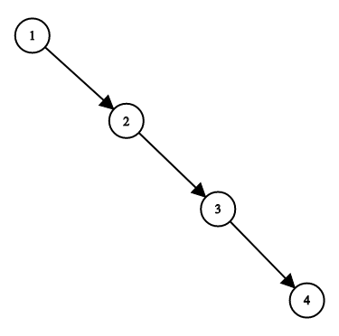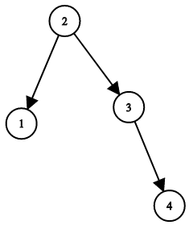

**Input:** root = [1,null,2,null,3,null,4,null,null]

**Output:** [2,1,3,null,null,null,4]

**Explanation:** This is not the only correct answer, [3,1,4,null,2,null,null] is also correct.

**Constraints:**

* The number of nodes in the tree is between 1 and 10^4.
* The tree nodes will have distinct values between 1 and 10^5.